Function Pointer assignments

Mandatory

1. WAP to invoke functions below based on user input character using function pointer. Character mapping and respective functions to be invoked are given below.

Character input Function

+ int add(int x, int)

- int sub(int x, int y)

\* int multiply(int x, int y)

/ int divide(int x, int y)

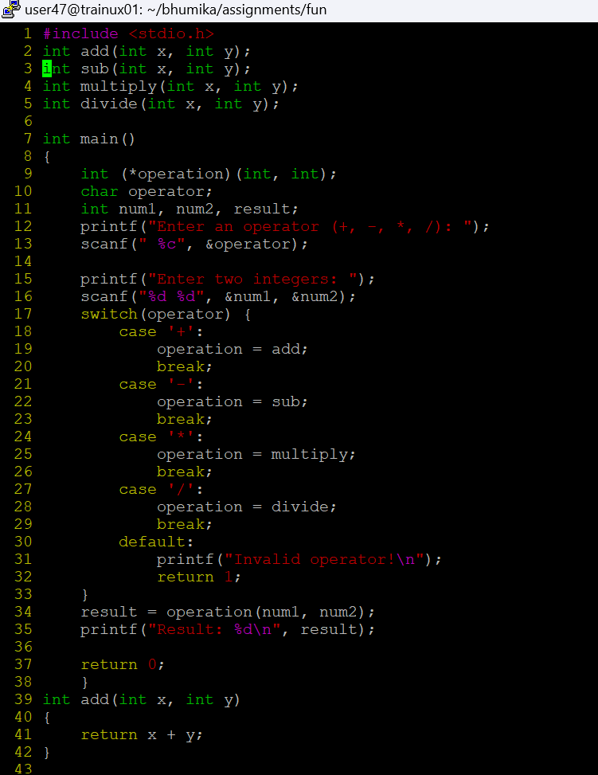

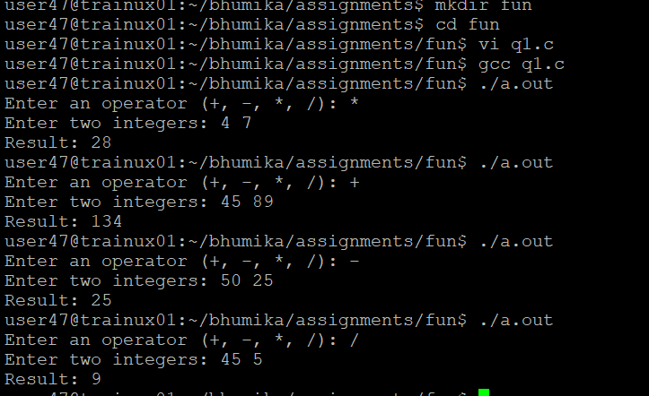

2. Extend Q1 to include a function below which will return the address of a function based on input character.

<address of function> getaddr(char mychar);

3. Extend Q1 to include a function below which takes a function pointer to a calculator function and one integer (value = 10) as arguments and shall invoke the given function with required arguments. For the second argument read input from user. Return the result.

int invokefunc(<function pointer as argument1>, int val1);

4. Extend Q1 to define an array of function pointers and invoke them based user input character

